Third Sunday of Lent  Joseph Milner  Reading I: Exodus 17:3-7 Responsorial Psalm: 95:1-2, 6-7, 8-9  Reading II: Romans 5:1-2, 5-8 Gospel: John 4:5-42  https://bible.usccb.org/Bible/readings/030721-YearA.cfm  The three Sundays at the heart of Lent (3rd, 4th, and 5th) invited us to reflect on our deepest desires and what blocks their fulfillment. The images are strong and invite us deep honesty with ourselves before God. | 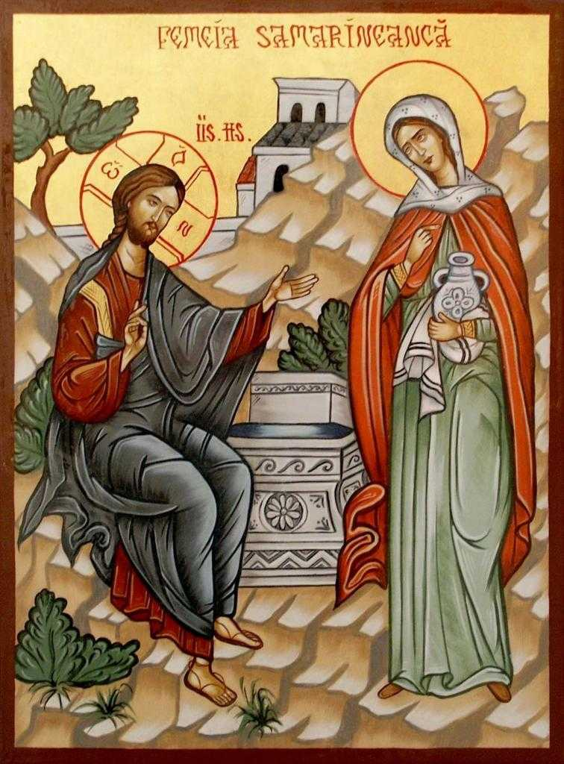
The passage from Exodus and the Gospel both highlight water as a symbol of life. In Exodus, the Israelite community is in the desert after having left Egypt. A desert is a harsh place, and they are struggling with a lack of water. God had led them out of Egypt with power acts of the plagues and the crossing of the sea. The mighty army of Pharaoh, king of Egypt, could not stop them. Now they feel abandoned in the desert with no water. God instructs Moses to strike the rock, and water comes forth. God is still with them. God has not abandoned them.
There are many times in life, as one faces challenges that we can each question whether God is still with us. Each person has desires and deep longings. These longings identify those desires that give shape to our life and where one puts energy.
Thirst is a powerful experience and is an image of what one wants. If you have ever been really thirsty, one remembers how everything becomes focused around quenching that thirst. So, in life, we thirst for or desire various things. It may be success, fame, or possessions. These are short-term quenching of our deepest longing.
In John's gospel, we encounter a literary structure that John uses to help the reader think more deeply. Jesus enters a conversation, and his words will be misunderstood. This opens the path for him to explain and guide the person to deeper insight.
For the original audience, there are two social elements that are scandalous in first-century Jewish culture. The Samaritans were considered unclean because their ancestors were part of the northern tribes of Israel who intermarried with their Assyrian conquerors and other defeated people. They once had true Israelite blood, and now they were mixed breeds. The Jewish community from the south (Judah) viewed them as impure and wanted nothing to do with them. Secondly, Jewish men did not speak to women in public. Men spoke to women at home, so generally only to those to whom they were related. Jesus breaks both these taboos and speaks to a Samaritan woman in public. The woman is caught off guard when Jesus asks her for a drink.
They then dialogue about water. Cisterns collected rainwater in the rainy season for use during the dry season. After being stored, it lost its freshness and was sometimes unappealing. It was referred to as dead water. Living water came from a spring that was fresh and renewing.
The woman has come to draw water, and Jesus offers her living water. That would save her time and effort. Jesus was referring to the inner life that he could offer, and she wants to know where he would get this water. He invites her to think more deeply.
The waters of baptism lead us to this life in Christ. In baptism, the Spirit of God abides in us, who is the source of all life. To enter this life, one must review one's life and surrender all that is deadly to God. Her response is to tell others whom she has met. This is the work of every disciple, whether by word or deed.

Justification has been a source of theological conflict between different Christian traditions. The understanding presented by the Catholic Church is that God works within us when we respond in faith (trusting reliance) in God. Justification is the beginning of the process. When one responds and grows in this relationship, salvation is the result. Humans cannot justify themselves. It is the work of the Holy Spirit who brings us into the right relationship with God. One can never earn that relationship with God, for God loves us far more than we realize. The length, breadth, and depth of God’s love is beyond our comprehension. Jesus died while we were sinners and invites us to accept the gift of new life that is affected by the Holy Spirit's coming in baptism. Our choice is to accept the gift or try to do it on our own. We will not succeed. Only God can bring us to new life.
Reflection Questions
What are some of the things for which you thirst (desire)?
In what ways do you thirst for God?
What do you notice about the Samaritan woman? What objections did the woman raise in her conversation with Jesus? What kind of change or growth was asked of her?
What obstacles (objections) have you encountered in growing close to Jesus?
How does your faith in Christ quell the thirsts of your heart?
Having encountered Christ, what are you led to do?
Has God brought you through some difficulty in an unexpected way?
Has God offered you gifts that you have not accepted?
How have you grown in your relationship with God in recent months?
Catechetical Themes:
Salvation Mercy and compassion
Baptism Human fulfillment

Prayer Suggestions:
For the Church, that we may be a source of living water for all who thirst for meaning and purpose in their lives
For a greater openness to the Word of God: that we may carefully listen to the scriptures, ponder them in our heart; and draw life from them
For the grace to seek authentic fulfillment: that we may daily seek Christ who fulfills our deepest longings and never be seduced by superficial satisfactions nor empty pleasures
For all who thirst every day: that God will assist all who lack water, guide all who are searching for new sources of water, and raise our awareness of the issues around water
© Joseph Milner, 2023

